**DOCUMENTATION FOR INVENTORY MANAGEMENT SYSTEM**

**STEP 1**

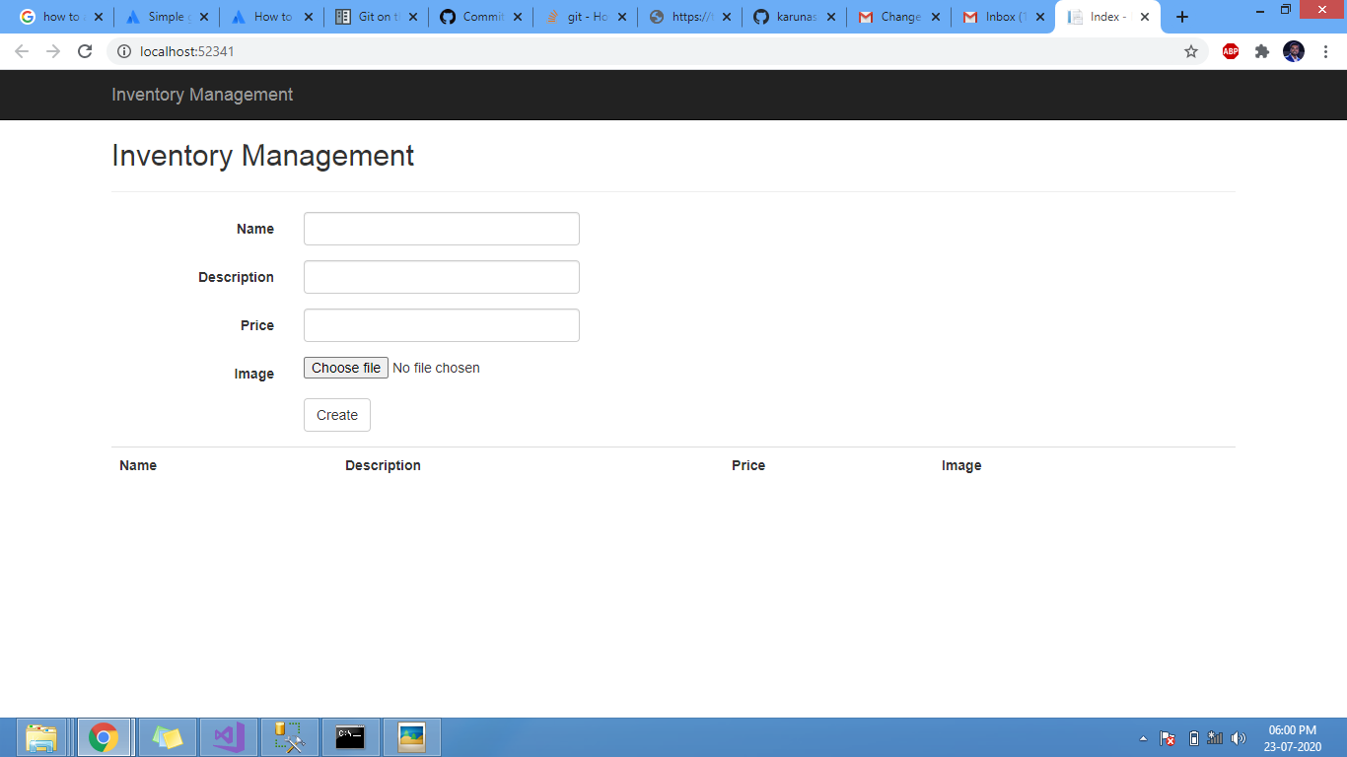

**In the home page we have to enter the name, description, price and image of the product.**

**STEP 2**

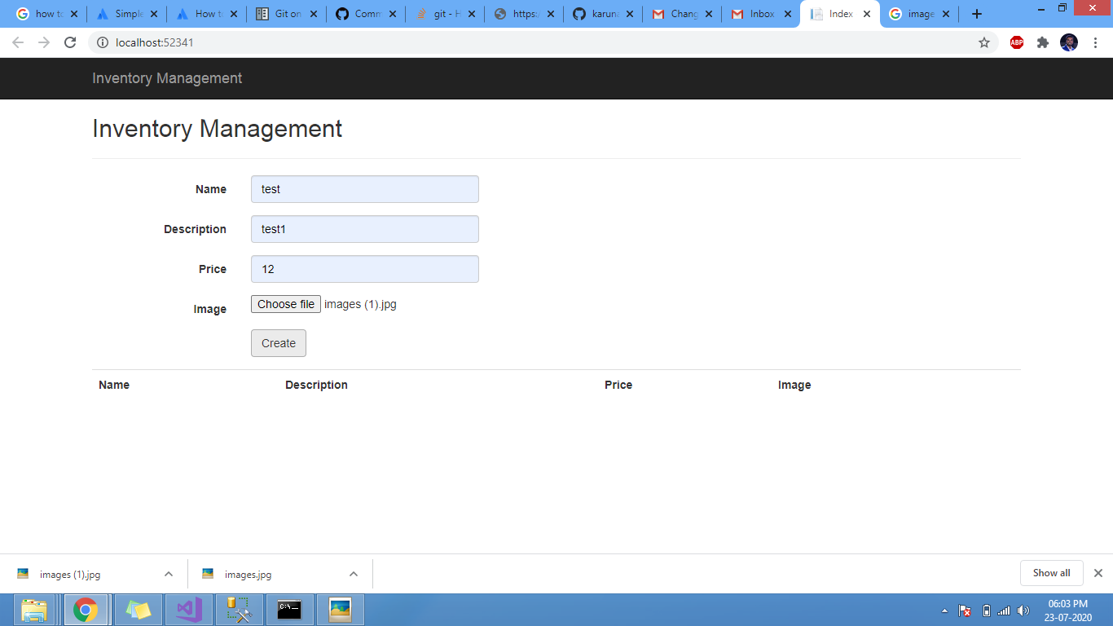

**After entering the details we have to click on create button to enter the product in the list.**

**STEP 3**

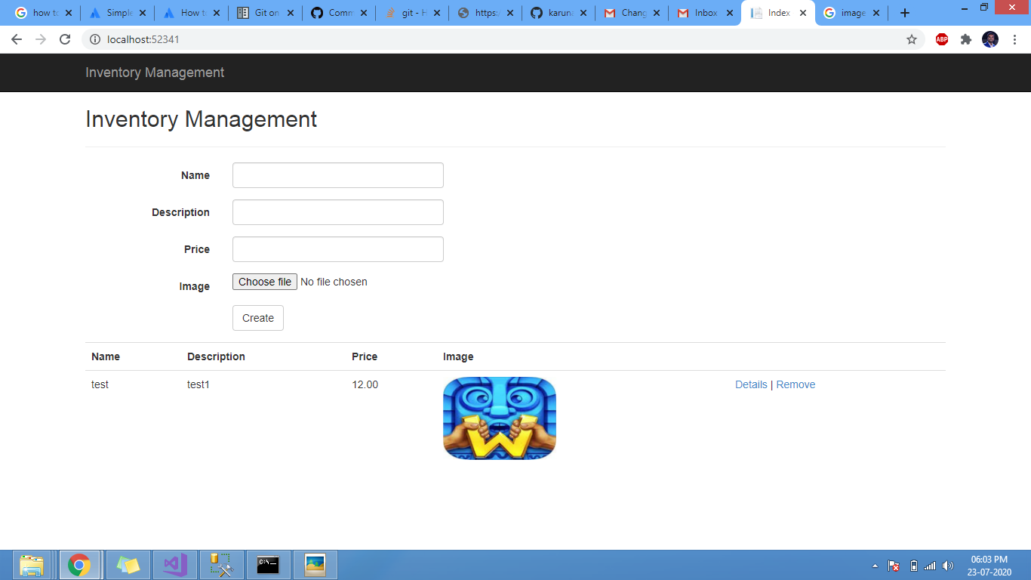

**As we can see that the product is entered in the list and is shown below, now we can click on details button located next to the image thumbnail to go to details page of the product.**

**STEP 4**

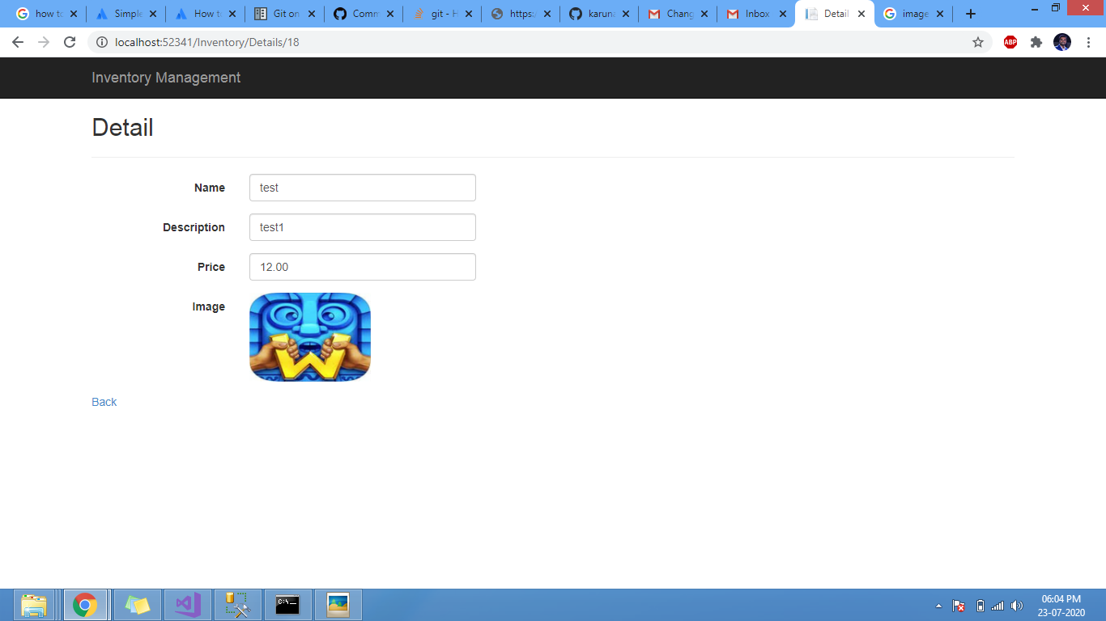

**This page opens as we click on details button located right next to thumbnail of the image. Also a back button given to go back to the products page.**

**STEP 5**

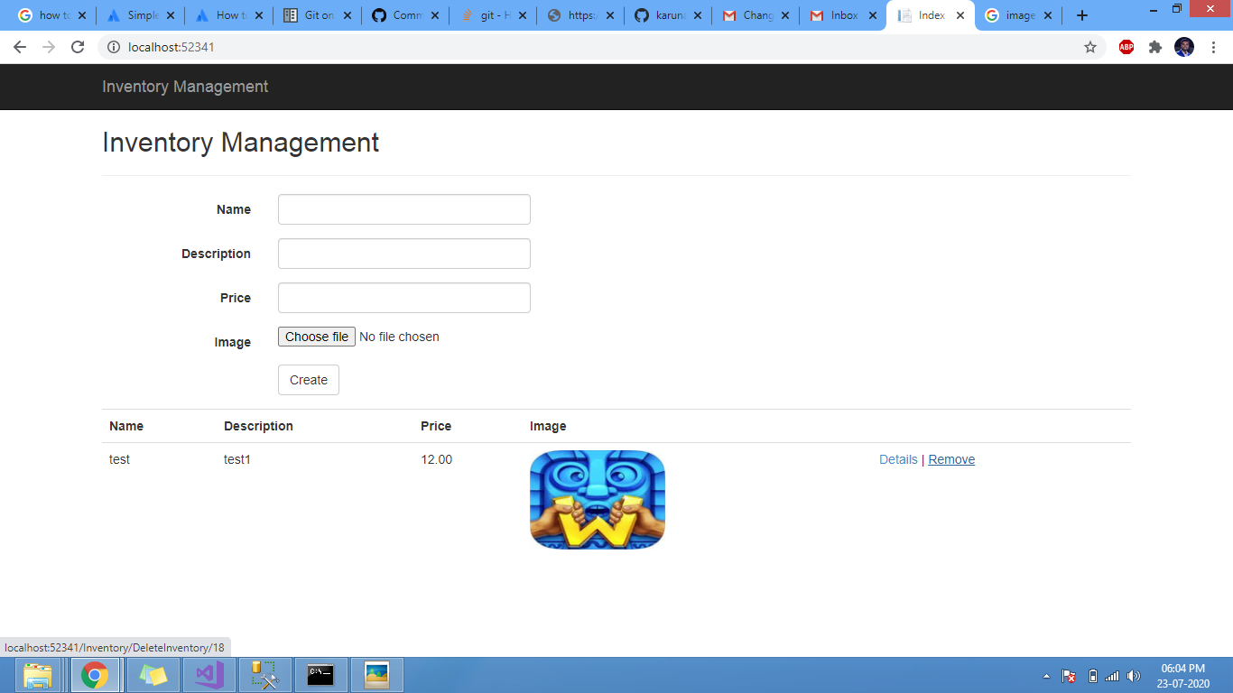

**In the products page, a remove button located next to details button is given to remove the product from the list.**